

**Flipkart Sales Dashboard Analysis**

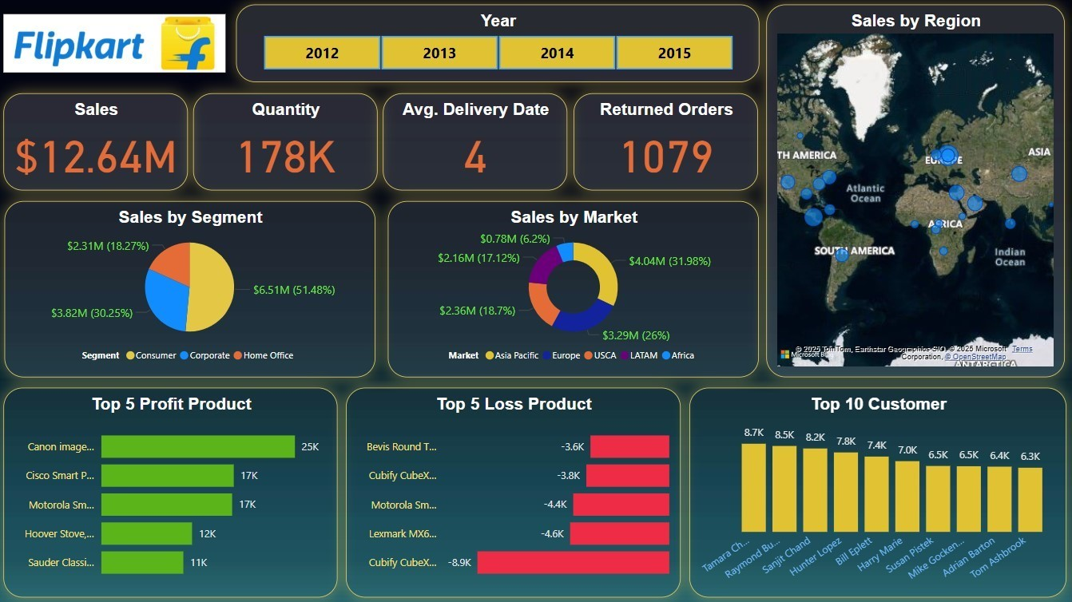

**Key Metrics Overview**

**Total Sales**: **$12.64M**

**Quantity Sold**: **178K units**

**Average Delivery Date**: **4 days**

**Returned Orders**: **1,079**

**Detail Analysis**

### 

### ****Sales by Segment****:

* **Corporate**: $6.51M (**51.48%**) — **Highest contributing segment**
* **Home Office**: $3.82M (**30.25%**)
* **Consumer**: $2.31M (**18.27%**)

**Insight**: Corporate clients are the biggest revenue generators. Targeted Business to Business strategies could increase profitability.

### ****Sales by Market****:

* **USCA**: $4.04M (**31.98%**) — **Top market**
* **LATAM**: $3.29M (**26%**)
* **Europe**: $2.36M (**18.7%**)
* **Asia Pacific**: $2.16M (**17.12%**)
* **Africa**: $0.78M (**6.2%**)

**Insight**: North America (USCA) leads in sales, followed by Latin America and Europe. Africa shows growth potential but is underperforming.

### ****Sales by Region (Map Visualization)****:

* **Strong sales presence in North America, Europe, and Asia**
* **Weaker presence in Africa and parts of South America**

**Insight**: Expansion strategies can focus on underrepresented regions like Africa and interior Asia.

### ****Top 10 Customers****:

* **Tamara Chu** (8.7K)
* **Raymond B** (8.5K)
* Other customers between 6.3K to 8.2K

**Insight**: There's a strong customer base with repeat high-value buyers. These should be retained with loyalty programs.

### ****Top 5 Profit Products****:

* **Canon imageCLASS 2200 Advanced copier** (25K profit)
* **Cisco Smart Phone,Full Size** , **Motorola Smart Phone,Full Size** (17K each)
* Others ranging from 10K–12K

**Insight**: Tech products are driving high profits. Emphasize marketing and stock availability of top profit items.

### ****Top 5 Loss Products****:

* **Cubify CubeX 3D Printer Double Head Print**: -8.9K — **Biggest loss maker**
* **Lexmark MX611dhe Monochorme Laser Printer** , **Motorola Smart Phone Cordless**: -4.6K, -4.4K

**Insight**: Some tech and office equipment are resulting in high losses. These products need review for pricing, demand, or quality issues.

**Conclusions**

**Strong Corporate Sales**: The corporate segment is the highest contributor; Flipkart should enhance Business to Business support and enterprise-level services.

**USCA is a Key Market**: The North American market brings in the most revenue; strategies should strengthen this lead and expand elsewhere.

**Product Strategy**: Focus on promoting top-performing tech products and reevaluate or discontinue consistently loss-making items.

**Customer Retention**: High-value customers exist and should be targeted with premium offers or retention incentives.

**Returns Management**: 1,079 returns suggest room for improvement in delivery, product quality, or expectation alignment.

**Global Expansion Opportunity**: Regions like Africa show low sales — potential growth areas with the right product-market fit.

**ISHA VERMA**

**Made By**